**Macintosh PowerBook 100系列**

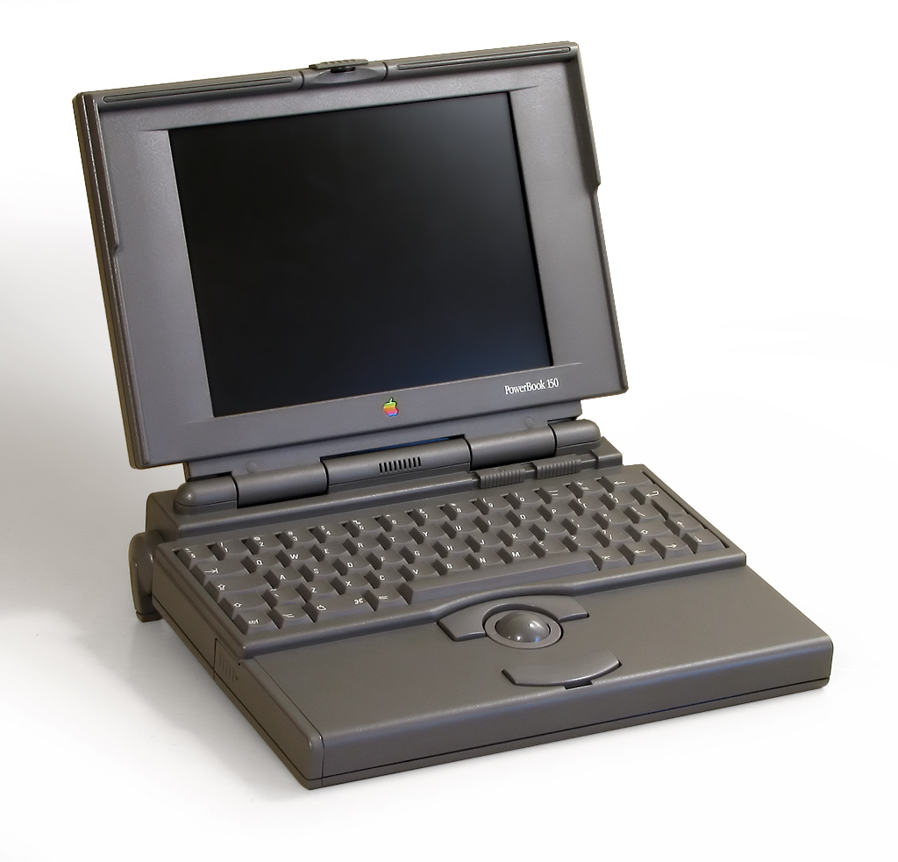

    1991年Macintosh PowerBook 100推出，是苹果真正意义上的便携式计算机。Mac Poertable虽然被确定为是便携式计算机，但是对于“便携”这一概念来说还是太过大和沉重了。因此，苹果又推出体积较小和轻的PowerBook。为了使它的重量尽可能的降到最低，所以此机内部减去了软驱。

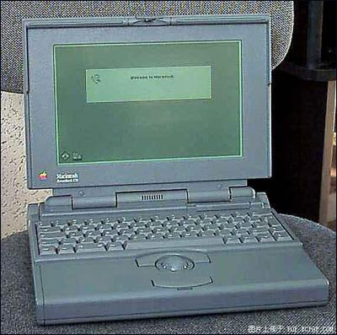

Macintosh PowerBook 100系列

    PowerBook 100被非常成功的推出后。PowerBook 140和170也相继的诞生。

    PowerBook 100系列是苹果公司1991至1996年推出的。其中在1995年推出的PowerBook 190，是唯一使用68LC 040处理器的PowerBook，被设计为低成本PowerBook。

**中央处理器速度：16MHz**

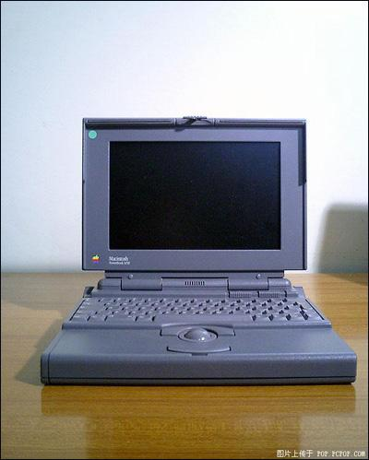Macintosh PowerBook

中央处理器： 68000  
中央处理器速度：  16 MHz  
协处理器：  
总线速度：16 MHz  
数据路径：16 bit  
内存类型：  
只读存储器: 2 MB  
最大的内存：8 MB  
总线插槽： 1 modem  
内存速度：100 ns  
VRAM:   
软盘驱动器：1.44 MB SuperDrive  
硬盘： 20/40 MB  
CD-ROM: ：  
ADB:1  
串口：  
显示器：passive-matrix LCD  
显示器支持：640 x 400, 1 bit  
视频输出：HDI-15  
以太网 ：  
Modem:   
CD-ROM: ：  
音频输出：8-bit mono  
音频输入：  
重量： 5.1lbs.  
功率：17 watts  
体积： 1.8 H x 11 W x 8.5 D   
操作系统：System software 7.0.1  
开始上市时间： 10月 21日 1991  
终止销售时间： 8月 3日 1992

**Macintosh PowerBook 140**

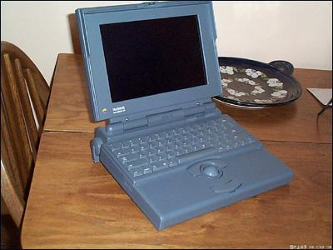

Macintosh PowerBook 140

中央处理器： 68030  
中央处理器速度：  16 MHz  
协处理器：  
总线速度：16 MHz  
数据路径：32 bit  
总线插槽： 1 modem  
内存类型：  
只读存储器: 2 MB  
最大的内存：8 MB  
内存速度：100 ns  
VRAM:   
软盘驱动器：1.44 MB SuperDrive  
硬盘： 40 / 80 MB  
CD-ROM: ：  
ADB:1  
串口：  
显示器：passive-matrix LCD  
显示器支持：640 x 400, 1 bit  
视频输出：HDI-15  
以太网 ：  
Modem:   
CD-ROM: ：  
音频输出：8-bit mono  
音频输入：  
重量： 6.8lbs.  
功率：17 watts  
体积： 2.25 H x 11.25 W x 9.3 D   
操作系统：System software 7.0.1  
开始上市时间： 10月 21日 1991  
终止销售时间： 8月 3日 1992

Macintosh PowerBook

|  |  |
| --- | --- |
| **Models:** | PowerBook 100, 140, and 170 |
| **Introduced:** | October 1991 |
| **Discontinued:** | October 1992 |
| **Price:** | US$2,299 - $4,599 |
| **CPU:** | Motorola 68030 @ 25MHz (170) |
| **RAM:** | 2MB minimum, 8MB maximum |
| **Battery:** | 2.5Ah NiCad |
| **Display:** | 640 X 400 monochrome LCD |
| **Ports:** | ADB, 1 or 2 serial, floppy, HD |
| **Storage:** | 1.4MB 3.5-inch floppy drive |
|  | 20MB, 40MB, or 80MB SCSI HD |
| **Comms:** | optional modem |
| **OS:** | Mac OS 7.01 - 7.6.1 |

详解[回目录](http://www.techcn.com.cn/index.php?doc-view-140603.html" \l "section)

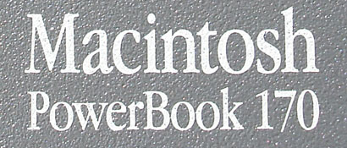

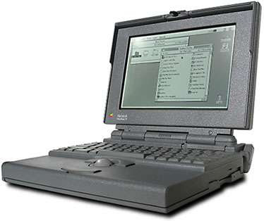  
On October 1991, Apple introduced the original PowerBook models: PowerBook 100, PowerBook 140, and PowerBook 170.   
  
All have different specifications and capabilties, with the model 100 as the lowest, and the model 170 the highest.   
  
While similar in appearance, the 140 and 170 were designed by Apple, with the 100 designed by Sony.   
Apple contracted with Sony to miniaturize the original Macintosh Portabl[e](http://oldcomputers.net/macportable.html) from 1989, itself a huge, heavy, beast of burden. The resultant PowerBook 100 is an improvement in almost every way - smaller, lighter, and cheaper.   
  
Like the Macintosh Portable, the PowerBook also uses an internal SCSI harddrive, which while considerably faster then the typical PC IDE hard drive, probably costs twice as much. They also have in common the "SuperDrive" floppy drive, which allows the PowerBook to read and write standard MS-DOS 1.44MB floppy disks. As the first really useful portable Macintosh computers, the PowerBooks were a great success for Apple, selling over 100,000 in the first three months alone, and sales in excess of $1 billion in the first year.   
  
The PowerBook 100 was also the most compact Apple computer for the next decade, until the Titanium PowerBook came out in 2001.

|  |  |  |  |
| --- | --- | --- | --- |
|  | **PowerBook 100** | **PowerBook 140** | **PowerBook 170** |
| **Designation** | Most Affordable | Mainstream | High Performance |
| **Price** | $2,499 | $2,899 | $4,599 |
| **Processor** | 68HC000 @ 16MHz | 68030 @ 16MHz | 68030 @ 25MHz 68882 FPU |
| **Display** | 9-inch Passive LCD | 9.8-inch Passive LCD | 9.8-inch Active LCD |
| **Floppy** | External (optional) | Internal | Internal |
| **Weight** | 5.1 pounds | 6.8 pounds | 6.8 pounds |

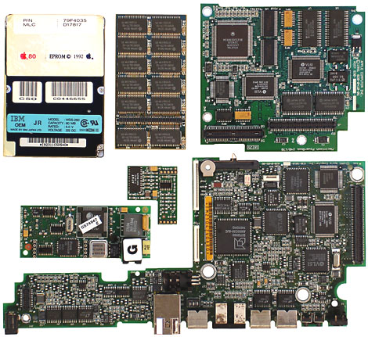

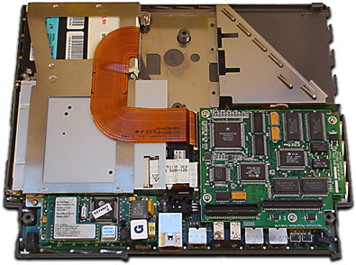

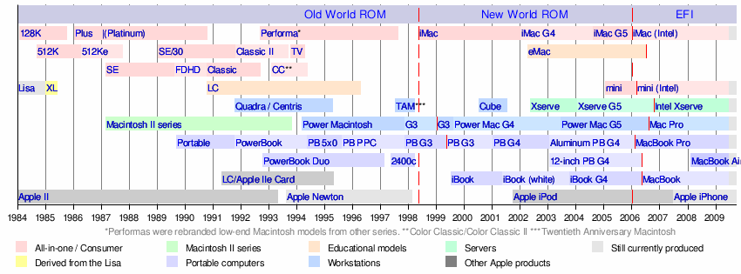

相关网站[回目录](http://www.techcn.com.cn/index.php?doc-view-140603.html" \l "section)

• [The PowerBook Museum](http://www.ryonix.com/powerbookmuseum/)

• [Vectronic's Apple World](http://www.vectronicsappleworld.com/profiles/351.html)

• [WikiPedia](http://en.wikipedia.org/wiki/PowerBook_170)

• [Low End Mac](http://lowendmac.com/pb/powerbook-170.html)

• [PowerBook 100 FAQ](http://www.open.ou.nl/psl/pb100/)

• [Kevin Omura](http://www.kevinomura.com/) has a lot of Apple computers.

• [Steven Matarazzo](http://www.stevenmatarazzo.com/) has lots of [old Mac documents](http://www.stevenmatarazzo.com/oldmac/)

• [Manuals from Apple](http://docs.info.apple.com/article.html?artnum=50594)

• [Apple's PowerBook specifications](http://support.apple.com/specs/powerbook/) - Specifications for G3 and later PowerBooks.

• [Apple-History](http://www.apple-history.com/)

• [Apple press release announcing January 2005 PowerBook revisions](http://www.apple.com/pr/library/2005/jan/31powerbook.html)

• [Video of Jobs launching PowerBook G4 Titanium at Macworld 2001](http://www.thestandard.com/news/2009/01/01/steve-jobs-greatest-macworld-video-hits-1998-2008?page=0%2C4)

• [Video of Jobs launching PowerBook G4 Aluminum at Macworld 2003](http://www.thestandard.com/news/2009/01/01/steve-jobs-greatest-macworld-video-hits-1998-2008?page=0%2C6)

参考文献[回目录](http://www.techcn.com.cn/index.php?doc-view-140603.html" \l "section)

http://en.wikipedia.org/wiki/PowerBook